October 4th, 2009
Hi
Well, this past week has certainly been a week of terrible natural disasters around the region. First there was a ferocious typhoon that caused the worst floods in Manila in the last 40 years. About 80% of the city has been under water and many houses and other buildings swept away in the torrents. A lot of this was shown on TV and it was grim watching to see people on debris being swept away to their deaths. The same typhoon then moved directly eastwards and created havoc first in Vietnam (in places such as Da Nang and Hue, which will be familiar names to anyone who followed the Vietnam war) and then in Cambodia. It must certainly have been strong to get so far inland before weakening. The winds of the typhoon did not affect HK much though it brought quite a lot of rain.
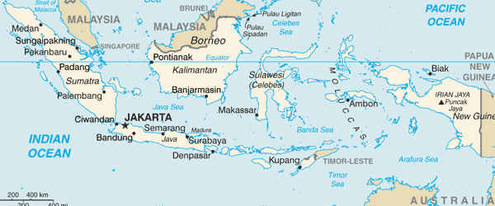
Then there was the 8.0 magnitude earthquake in the Pacific Ocean close to the islands of Samoa, Western/America Samoa and Tonga. A large tsunami destroyed a large area of Samoa. Fortunately, it happened during the day and also that people had been trained what to do when a tsunami alert was issued, such as fleeing to the hills. But still many were killed, including 13 members of one family (covering four generations). Some Australians, who were surfing at the time, also lost their lives.
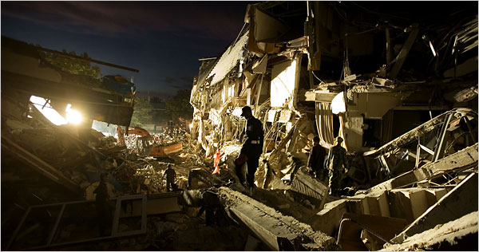
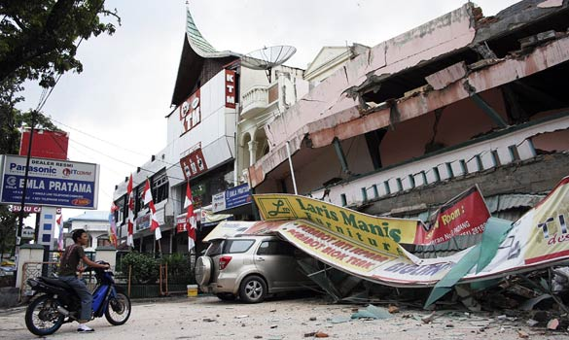
This was followed by a 7.6 magnitude earthquake in the city of Padang in Sumatra, Indonesia. This was one of the places I visited while in Indonesia last November. Many buildings, including hotels and schools were flattened. The top picture shows a famous hotel but is not the one I stayed in. Even though Padang is on the coast there was no tsunami as the earthquake was deep under the land and not under the sea. This coming November, I was supposed to go again to Padang but I guess that will be cancelled now. That night I got a phone call from Gavin at midnight to check that I was still in HK and not in Indonesia. (I remember last year when I in Indonesia there was a 7.6 quake though where I was I did not feel anything.)
There was also a 7.6 magnitude earthquake south of New Zealand though I have not heard any reports of damage. Although all three earthquakes are on fault lines along the ‘ring of fire’, seismologists do not now think they are related. Talking of earthquake magnitudes, do you know what the numbers mean? The scale is called the Richter scale and it is a logarithmic and not a linear scale. Thus a magnitude 2 earthquake is not two times as powerful as a magnitude 1 quake but 10 times. Reason:
Magnitude : 1 2 3 ………. 7 8
Force: 10¹ 10² 10³ ……….. 10⁷ 10⁸
i.e. 10 100 1000 10000000 100000000
Although the difference in magnitude between the Samoan and Indonesian quakes in only 0.4, the actual different in strength is 10^{0.4}, which (using my calculator) is 2.5. So the Samoan quake was 2.5 times as powerful as the Padang quake. However, the actual devastation caused depends on factors such as distance away, depth of quake.
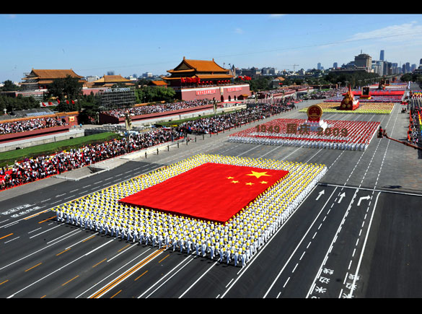
Thursday, October 1st, was China’s national day. Doubtless you will have seen some of it on TV. It was the 60th anniversary of the founding of the PRC and as ‘60’ is a special number (I don’t know why), the day was even more important. However, for many, including people in China, it was a day to be marked and not celebrated. As the country is ruled by one party, a spectacular event is needed to convince the masses that under their rule, the country will prosper (as it has been) and that they have the ‘mandate of heaven’ which Chinese emperors used to refer to as their mandate to rule does not come from the people as in a democracy. It did seen to convince the masses. The celebration was more about the Communist Party congratulation itself. Hence, such spectacles are less likely in democracies. Also, locals and tourist were not allowed to watch the parade. They were told to stay at home or in their hotels and watch it on TV. The only people lining the route were those from around the country who were invited. And people who lived along the route were told not to go out onto their balconies or risk being shot!
On National day evening, the hotel had its annual ‘mid-autumn festival’ party from serviced-suite guests. It is usually held at the pool but because of inclement weather (due to above-mentioned typhoon), it was held downstairs in the lobby. I go because of the free food!
As the typhoon passed last Monday, it seemed to give perfect conditions for swimming - no sun, no wind, nice light rain, no people, calm water and 'goldilocks' water temperature, that is not too hot, not too cold but ‘just right’ (like the porridge).
On TV I saw a repeat of the documentary 'Sick around the world' by T R Reid, who is/was a Washington Post reporter. Because of the debate over health care in the US, he visited five other countries (UK, Japan, Taiwan, Germany and Switzerland) to see what kinds of health care they offered and what the US could, but probably won’t, learn. All five offered ‘socialised’ health care with the government having a very big say. Even Switzerland, with all its pharmaceutical and insurance companies, and which used to have a system as in the US, now rigidly controls their health system. All five countries also see that there are severe limits to free market health care, which the US seems to be blind to. In the various countries he asked two questions: How many people die every year due to being unable to see a doctor and how many go bankrupt as a result of not being able to pay medical expenses? The answers to both questions were ‘zero’ (or words to that effect). In the US, the answers to these questions are 20 000 and 700 000 respectively! At the end of the documentary he compared the US system with these five countries. In the US, the best of the VA system is similar to the UK’s NHS. For those with good private insurance cover, it is not unlike the German system. And Medicare (?is that the system for the elderly) is similar to Japan’s(?). But then comes the final crunch line: For the 47 million in the US who have no health insurance, we (i.e. the US) are just like any third word country! A few weeks ago, Time magazine reviewed a book written by Reid as a follow up to his documentary (see picture), and the reviewer gave it a ‘read’ rating (the other ratings being ‘skim’ and ‘toss’).
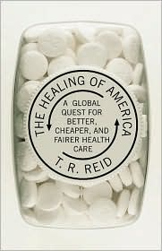
Yesterday was mid-autumn festival holiday. The Philippines has been battered by another typhoon, with winds up to 230 km/h but less rain than last week’s typhoon. It was heading for Manila but veered north.
That’s about it.
Cheers

